Step 1: Download Java JDK
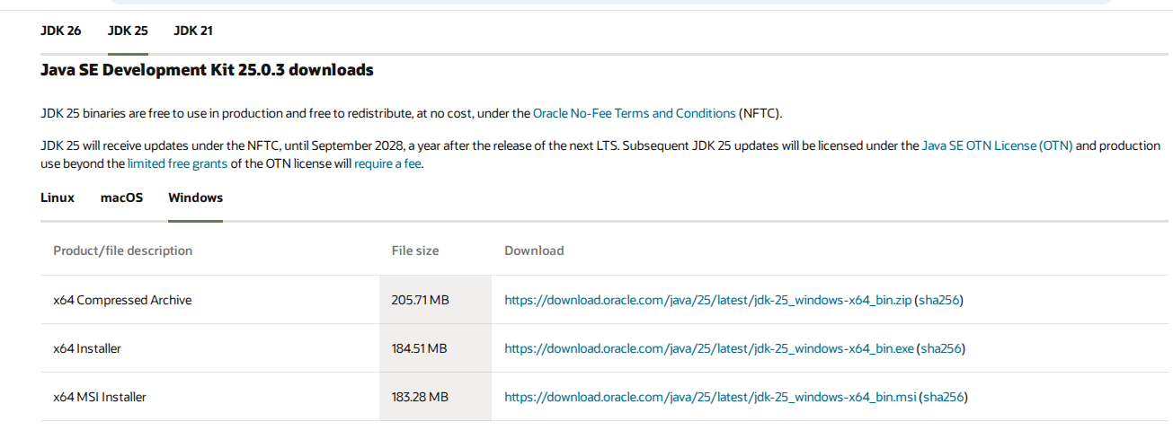
Step 2: Install JDK
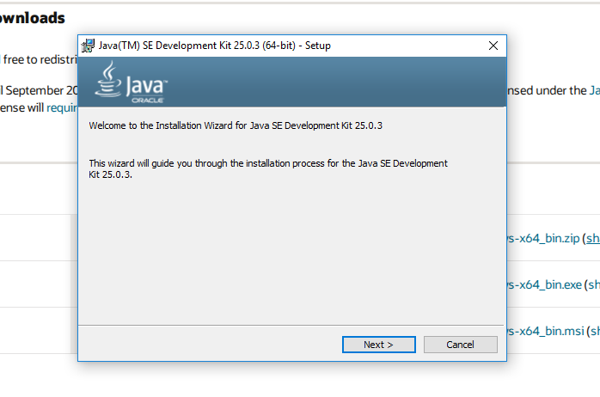 Step 3: Verify Java Installation
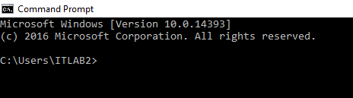

Step 4: Type java –version
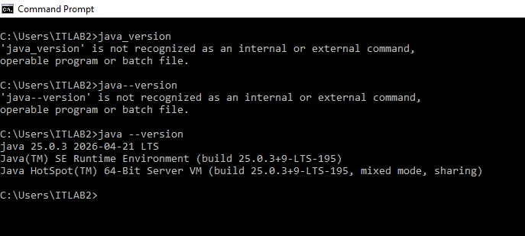
Step 5: Type javac –version
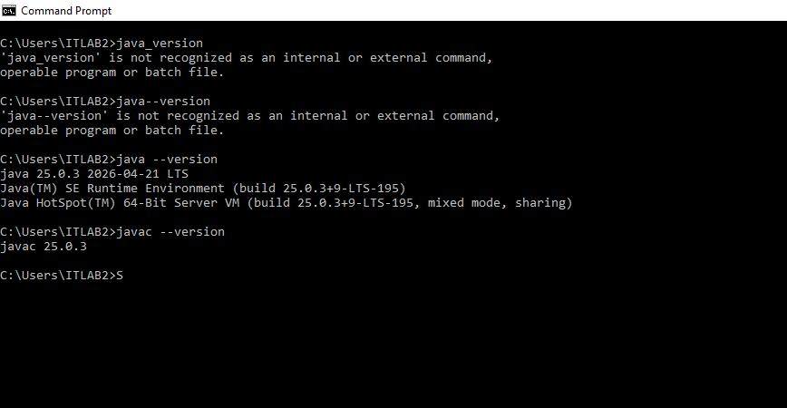

Configuring Java on Windows (Setting JAVA_HOME and PATH)
Step 1: Press Windows + R and type sysdm.cpl for setting the path
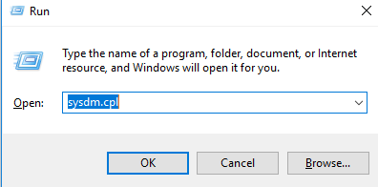
Step 2: Select Advanced
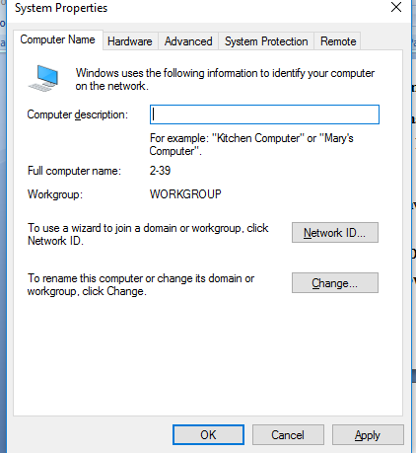
Step 3: Select Environment Variables
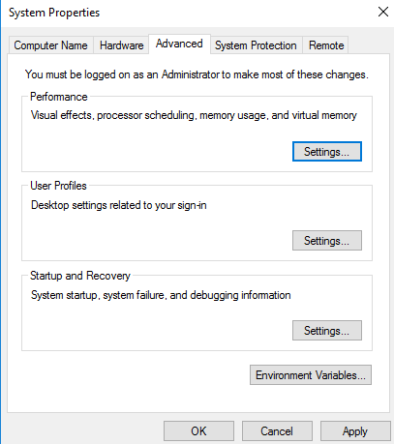
Step 4: In System Variables click new
And type Variable Name: JAVA_HOME
Variable Value: C:\Program Files\Java\jdk-25
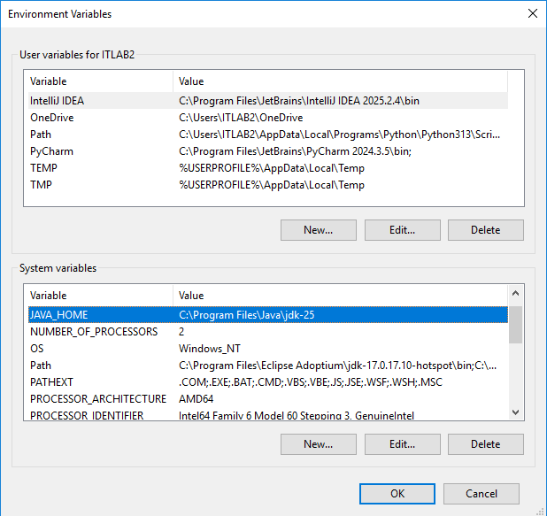
Step 5: Under System Variables, select Path.
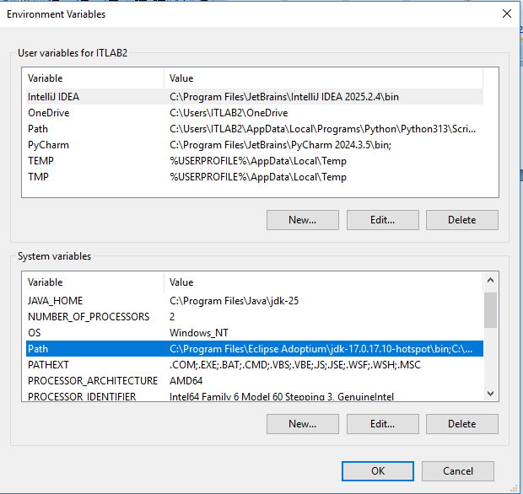
Step 6: Then click edit and click new and add %JAVA_HOME%\bin and then click ok->ok->ok
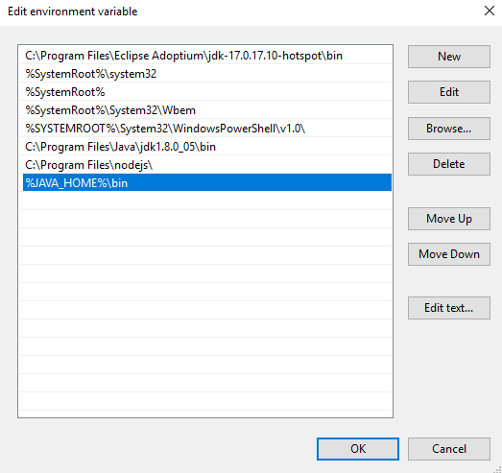

Step 7: Verify Configuration
Open a new Command Prompt and execute
echo %JAVA_HOME% and the output should be C:\Program Files\Java\jdk-25
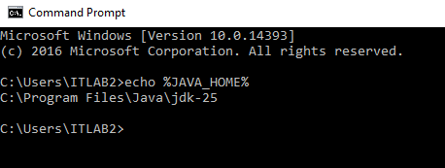
Step 8: Check the version through java –version and java –version


